How to create an Excel Web Query

1. Open Excel in the desired spreadsheet, and select the cell that you would like the data to be imported into.
2. Select the Data tab, then select From Web.

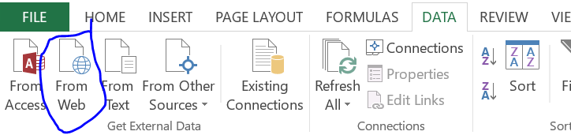

1. Type in the website you would like to grab data from.



1. Make sure that the URL to the website is correct, with all required parameters and login data.  
   For example, in many of my web queries, I had to append ?user=username&password=pass to many of my urls. Every website is a little bit different, so keep that in mind.
2. If you wish to query the website, you must either find the URL to it’s database, or use an API to indirectly access the database. This too, will be specified in the website’s URL.
3. Click the save button and select a location that you would like to save the web query file.
4. Select this button: 
5. Next, select the data table that you would like to use.

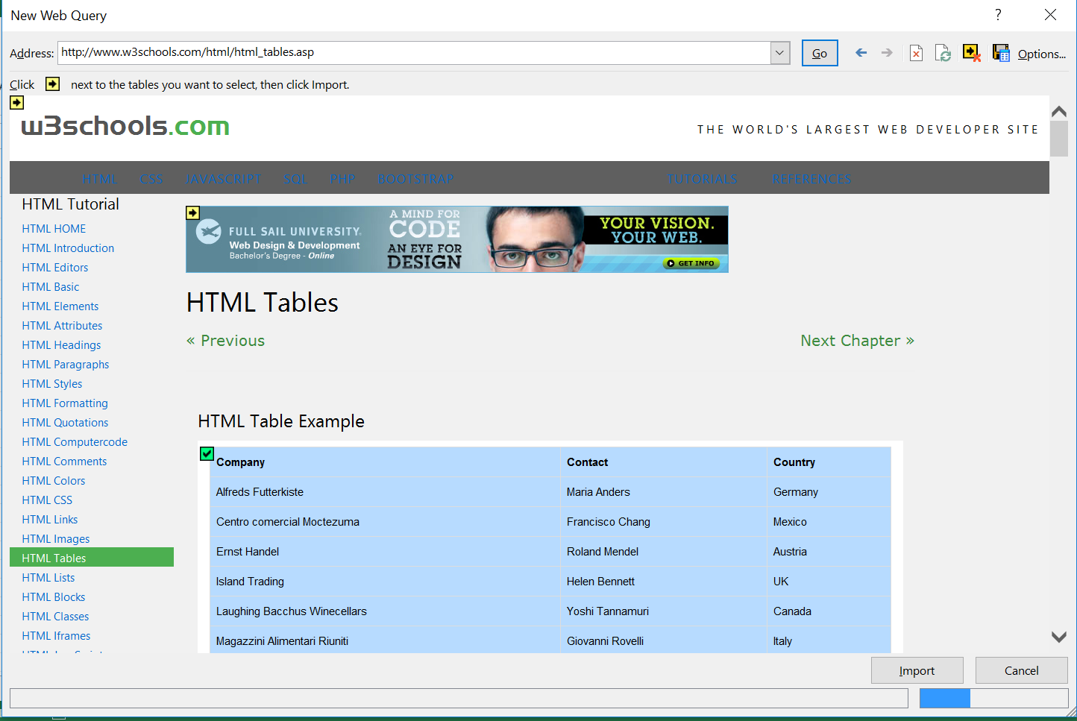

1. Finally, select the import button, and as you can see, the data has been imported and the web site has done exactly what you asked, based on the URL.
2. Note: In this project, I had used a language similar to SQL within the URL in order to query the Crucible database. If you have access, likely your SQL code will be present in the URL.

Modifying an Excel Web Query File

1. Go to the location that you saved the previous Web Query file, and skip to step 3 if you are able to find the file.  
    If you do not remember this location, select data, Existing Connections, Click on your connection, right click and select “edit connection properties”.

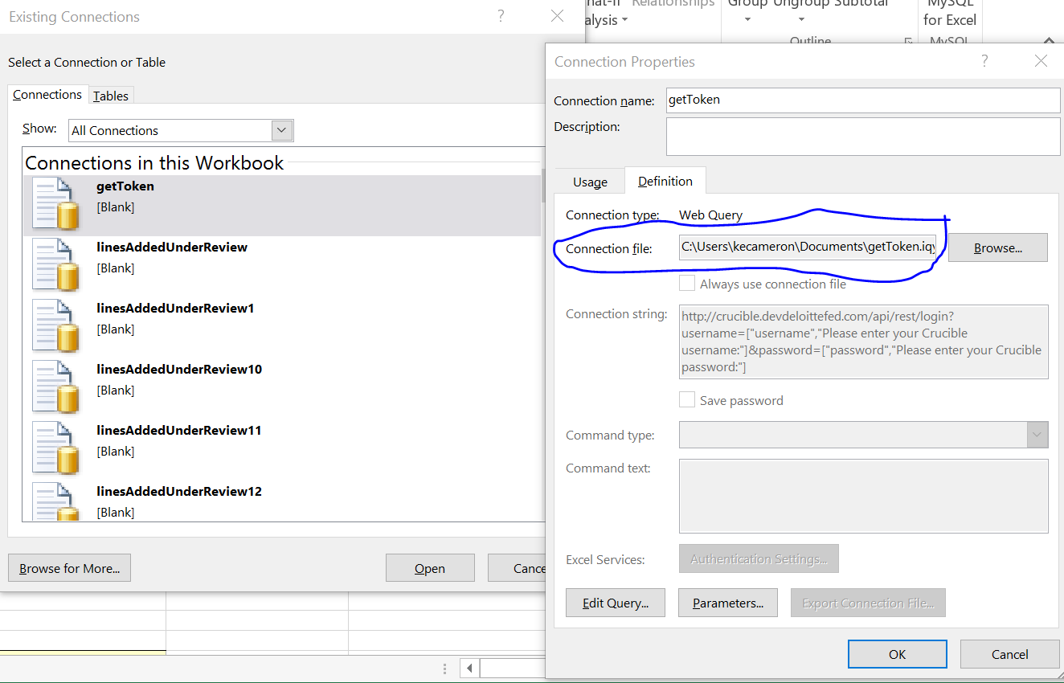

1. Your connection file will be listed within the definition tab of the Connection Properties window. Take note of the file path, so you can open the file.
2. Navigate to the connection path within your windows explorer, and open the file in Notepad. You are looking for a .iqy file.
3. When you open the file, it will probably look something like this:

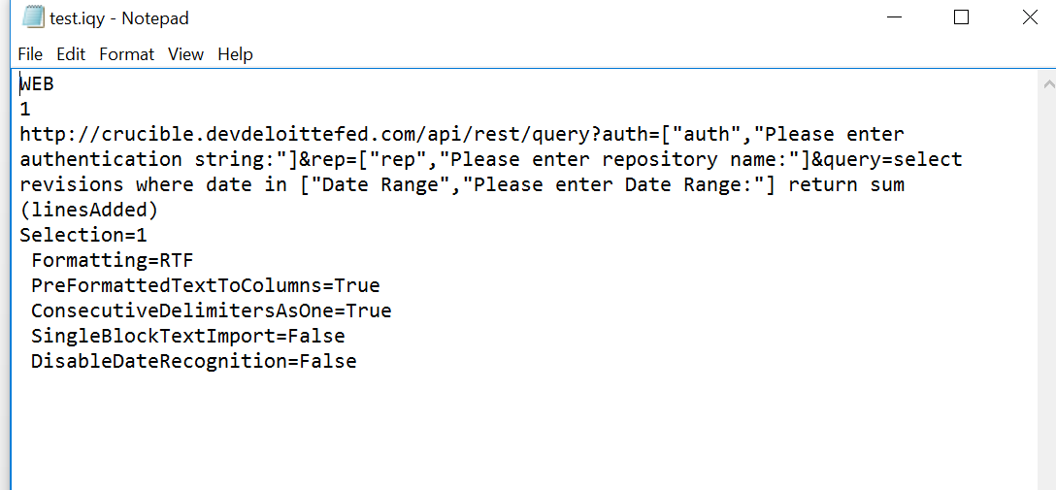

1. If the bottom lines (selection, formatting, etc) are not there, add them, or modify them to your needs.
2. Notice in the picture, that whenever I need to define a custom parameter, I can type [“parametername”,”parametermessage”] to give the user a chance to type in data. This allows you to access different accounts within the same website, based on the credentials sent to the website.
3. As you can also see from the picture, my particular query was actually a parameter within the URL. If you are trying to query a remote database, this may be helpful for you to follow.

Modifying Excel Web Query Parameters

1. Follow steps 1 and 2 in the Modifying Excel Web Query’s section of this document.
2. Once you come back to this screen, open the definitions tab for your connection.

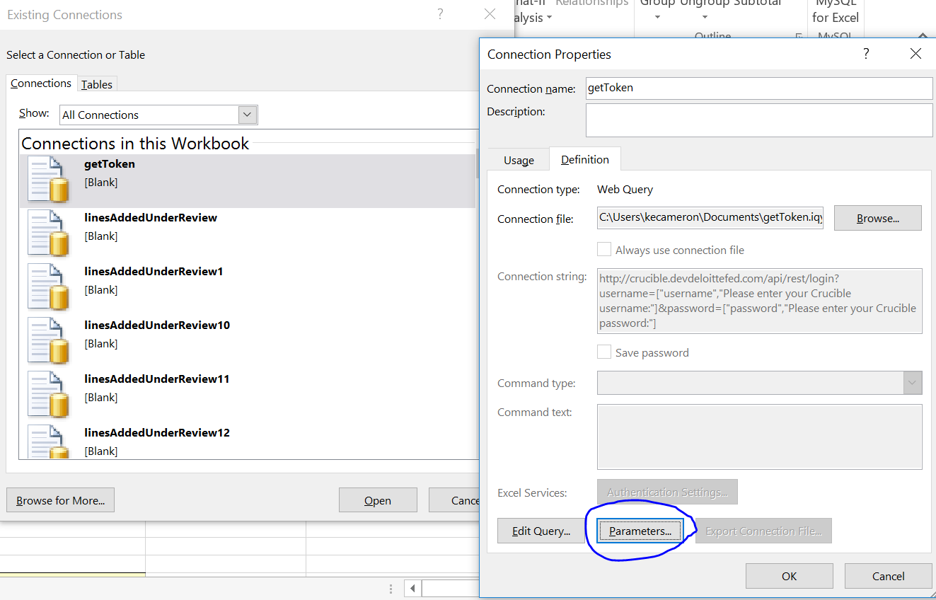

1. Here, there is a button that is labelled “parameters”. Select it. If this button is greyed out, then go back to the previous section and change your web query to support additional parameter user input.
2. After that, you are free to choose how you want the data to be inputted. You can have the user type it in every time, use the same value every time, or you may select a cell to grab the data from.

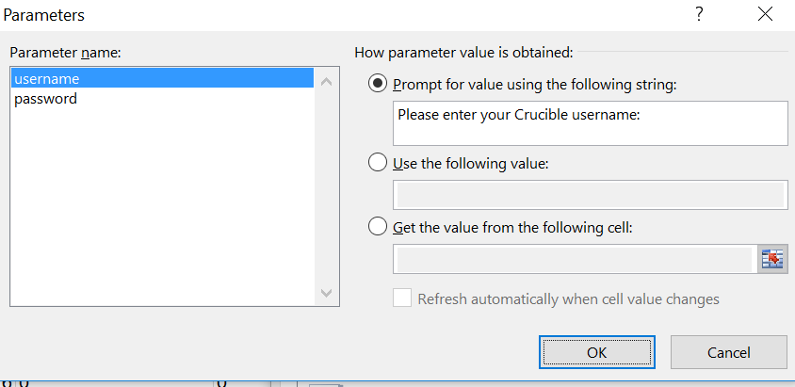

Other Helpful Information from Microsoft:

Change the custom prompt for a parameter query

1. On an Excel worksheet, click a cell anywhere in an external data range that was created with a parameter query.
2. On the **Data** tab, in the **Connections** group, click **Properties**.

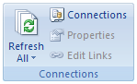

1. In the **Properties** dialog box, click **Connection Properties** Button image.
2. In the **Connection Properties** dialog box, click the **Definition** tab, and then click **Parameters**.
3. In the **Parameters** dialog box, in the **Parameter name** list, click the parameter that you want to change.
4. In the **Prompt for value using the following string** box, type the text that you want to use for the prompt, and then click **OK**. The custom prompt can contain up to 100 characters.
5. To use the new custom prompt and refresh the data, click the arrow next to **Refresh All** on the **Data** tab, in the **Connections** group. Then click **Refresh**.
6. In the **Enter Parameter Value** dialog box, the new prompt is displayed.

**Note:** Optionally, to prevent being prompted again during each refresh operation, you can select the **Use this value/reference for future refreshes** check box. If you use data from a cell as the parameter value, select the **Refresh automatically when cell value changes** check box.

**Note:** The preceding procedure changes the custom prompt only for the current session of the workbook. If you want to permanently save your changes to the custom prompt, save the workbook or change the prompt for the query. For more information about changing a query, see Microsoft Query Help or [Get external data from a Web page](http://office.microsoft.com/redir/HA010218472).

[Top of Page](https://support.office.com/en-us/article/customize-a-parameter-query-addf7cb7-ddf0-442f-a60c-cd7280e201bd" \l "top)

Use data from a cell as a parameter value

1. On your worksheet, type the values that you want to use as criteria in the query.
2. Click a cell anywhere in the external data range that was created with a parameter query.
3. On the **Data** tab, in the **Connections** group, click **Properties**.



1. In the **Properties** dialog box, click **Connection Properties** Button image.
2. In the **Connection Properties** dialog box, click the **Definition** tab, and then click **Parameters**.
3. In the **Parameters** dialog box, in the **Parameter name** list, click the parameter that you want to change.
4. Click **Get the value from the following cell**.
5. On the worksheet, click the cell that contains the value that you want to use.

If you want to refresh the data whenever you change the value in the cell, select the **Refresh automatically when cell value changes** check box.

1. Click **OK**.
2. To refresh the data, click the arrow next to **Refresh All** on the **Data** tab, in the **Connections** group. Then click **Refresh**.

Use a constant parameter value for a query

1. In Excel, click a cell in the external data range that was created with a parameter query.
2. On the **Data** tab, in the **Connections** group, click **Properties**.



1. In the **Properties** dialog box, click **Connection Properties** Button image.
2. In the **Connection Properties** dialog box, click the **Definition** tab, and then click **Parameters**.
3. In the **Parameters** dialog box, in the **Parameter name** list, click the parameter that you want to change.
4. Click **Use the following value**.
5. Type the value that you want to use for the parameter, and then click **OK**.
6. To refresh the data, click the arrow next to **Refresh All** on the **Data** tab, in the **Connections** group. Then click **Refresh**.